Ghost Cave, Eastern Himalayas, Bhutan.
John All, Chris Groves, and Pat Kambesis.
Hoffman Environmental Research Institute, Western Kentucky University, 1906 College Heights Blvd #31066, Bowling Green, KY 42101, USA. john.all@wku.edu

Abstract

Limestone deposits in the country of Bhutan are relatively sparse and caves are rare because of the rapid uplift of the Himalayas. The major limestone units that do exist, which have been geologically investigated in the context of mining for cement production, occur mainly in the lower elevations of the country’s south. However, two caves have been documented in the country to date; one in the Bumthang district and the other near Kahling in eastern Bhutan. In November 2004, a reconnaissance expedition was fielded to the Bumthang district to investigate ‘Ghost Cave’. The cave, with an entrance elevation of 3,152 meters, is two hundred meters in length with a mapped vertical extent of thirty-five meters and a steady downward slope. Cave development appears to be a function of turbulent flow as opposed to fracturing which also might be possible in such an active tectonic environment. Secondary mineralization in the form of speleothems reflect heavy precipitation that is typical of Asian monsoon seasons. The cave shows evidence of a long history of speleothem collection and local interviews confirmed that these features have been used as religious offerings. While Buddhist religions generally have a ‘soft’ environmental impact, for Ghost Cave the impact to speleothems has been severe.

Introduction

The Himalayan Mountains are the largest on Earth and are still actively growing at the geologically rapid rate of over a centimeter per century as the subcontinent of India collides with Asia. The Himalayans stretch in a long arc along India’s northern border; nearly reaching Pakistan to the west and Burma to the east. Limestone deposits in the Eastern Himalaya are relatively sparse (Gassner, 1983; Jangpangi, 1971) and when combined with the rapid uplift of the landscape mean that there has been very little cave development. The Eastern Himalayas are part of the upper watershed of the Ganges-Brahmaputra-Meghna River Basin, which has the third largest watershed runoff in the world after the Amazon and the Congo-Zaire Basins (Bandyopadhyay, 2002) and rainfall averages 500-1000 mm per year in the lower alpine elevations. Under these cool moist conditions, limestone dissolution and cave formation is possible if local erosion is more rapid than geologic uplift.

Bhutan and the Eastern Himalayas

Bhutan is the only independent country remaining of the isolated Buddhist Kingdoms. The others have been absorbed by China or India. Bhutan is located on the southern edge of the Eastern Himalayas with Tibet to its immediate north. India surrounds the other sides and is Bhutan’s major ally (helping buttress against a potential invasion by China (Staff, 2004)). Bhutan hosts numerous Indian soldiers and India maintains several training facilities and bases in Bhutan. Indian is also Bhutan;’s major trading partner and the major consumer of Bhutan’s number one export – electricity. Nepal is very close to Bhutan’s eastern border and Bangladesh is near the southern border and also a major trading partner. Bhutan is an extremely rugged country with a major elevational gradient. The country stretches 200 km north to south and the elevation changes from less than 100 m to over 7500 m. Overall, less than eight percent of the country is available for agriculture due to the steep slopes and soil composition (Baillie et al., 2004).

This reclusive Kingdom has been essentially closed to outsiders for most of its history and even now it is very difficult and expensive to gain access for research purposes. However, thanks to some good contacts and luck, the Hoffman Institute had the opportunity to explore the karst regions of Bhutan with financial support from the Western Kentucky University Office of Sponsored Programs and logistical support from the World Foundation for Environment and Development. Most known caves (normally ‘shelter’ caves) in Bhutan are associated with religious figures and have served as long-term meditational retreats. Caves have long been associated with religious figures in the Buddhist religion because they provide instant, temporary shelter for a person to retire and meditate for a period without having to create a hut or other domicile. Also, they are associated with overcoming the demons that are thought to dwell within such dark spaces. Most of the caves are small shelter-type overhang caves rarely more that 5 meters deep. Reconnaissance by the author of various rumored caves in the study area revealed this to be the dominant cave type.

During the expedition, it was decided to focus on an area that contained a rare limestone cave located in the province of Bumthang (Motegi et al., 2001). Bumthang is located in the north-central part of Bhutan and is relatively flat compared to most of the rest of the country. Population density is relatively higher in this province than elsewhere due to the flatter land and increased agricultural opportunities. The high population density means that existing caves are more likely to have been encountered. In Bumthang there were rumors of additional caves and similar rumors persist throughout the poorly explored east and south of Bhutan.

Ghost Cave

The cave, with an entrance elevation of 3,152 meters, is two hundred meters in length with a mapped vertical extent of thirty-five meters and a steady downward slope. According to local residents of Ugyen Chholing (the small village nearest the cave), Ghost Cave is the local name for the cave. The cave developed by turbulent water flow rather than simple fracturing. The cave mostly follows the dip of the local strata, though for a short segment, does trend on the strike (Motegi et al., 2001). The cave’s passages are tube-like and thus probably phreatically formed (Palmer, 1991). It is speculated that the cave is an old meander cutoff of the massive Tang River. Ghost Cave is well decorated with speleothems – derived from the heavy precipitation associated with the Asian Monsoon

The cave entrance is formed at the contact between a calcite formation and a calcarenite formation. The existence of the cave raises the question of whether tectonic stability would have been required over the period of the cave’s evolution in an otherwise continuously uplifting tectonic regime. Calcarenite (a sandstone-like rock composed of calcite rather than quartz particles) is susceptible to very rapid physical and chemical erosion and thus it is possible that only a short period of stability would have been required to form the cave. The cave passage’s lowest level ends with breakdown on the floor and strongly blowing cool air issuing from the breakdown blocks, suggest that the cave continues beyond what is currently known.
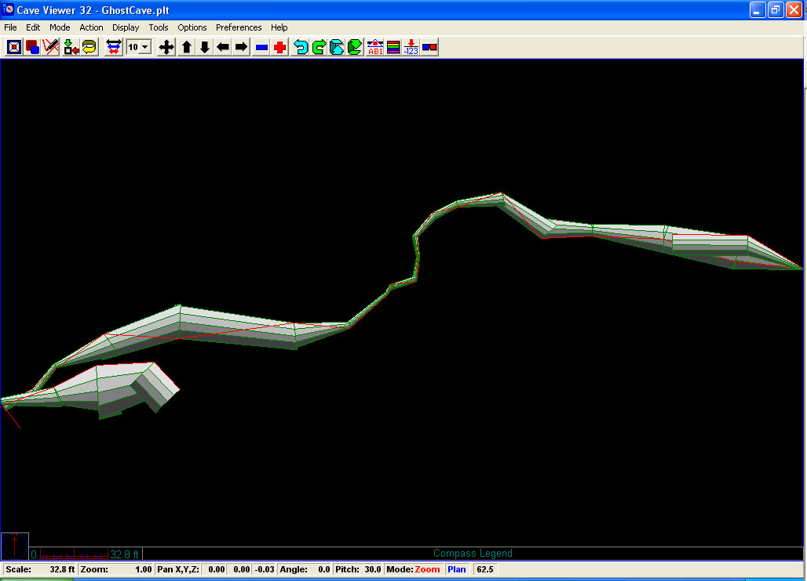

Figure 1: Plan View of Ghost Cave, Ugyen Chholing, Bhutan. The entrance is at the far right.

Caves and Nyingma Buddhism

Guru Rimpoche (the most important of Bhutan’s spiritual and historical figures) was first invited into Bhutan to save a local ruler from a cave-dwelling demon (Armington, 2002). Traditionally, such demons are faced by ‘enlightened’ figures, such as Guru Rimpoche, who are buoyed with Buddhist spiritual power. The demons are usually converted by this spirituality into a protective Buddhist deity for local areas according to interviews. After the successful conversion of this particular demon (called Shelging Karpo), Guru Rimpoche used the cave to meditate for several years before he began traveling and teaching in Bhutan. The cave is now part of a temple complex called Kurjey Lhakhang and it is considered so holy that when the kings of Bhutan die, their bodies are cremated here. Guru Rimpoche and other figures such as Ngawang Namgyal (the founder of the country of Bhutan) and Pema Lingpa have a variety of caves associated with them including Taktshang Goemba (Tiger’s Nest), Gom Kora, and Membartsho (Burning Lake; which is surrounded by small shelter caves) among many others.

Speleothems in these types of shelter caves are exceedingly rare but when they have been encountered they are removed and placed on alters, in shrines, or in chortens according to interviews with the local residents. Chortens are sealed religious structures built to surround and protect a holy artifact and desecration of these chortens is one of the most heinous of crimes in the Buddhist religion; equal to or surpassing murder (very striking in this vegetarian, non-killing focused religion) and in Bhutan results in a lifetime jail sentence. Based on local interviews, chortens are created by governments to appease local spirits and ward away floods or traffic accidents. A special set of chortens near the capital (Thimphu) was created after a border skirmish in order to atone for the nation’s spiritual burden resulting from killing their enemies. Individuals generally create a chorten as a means of getting good karma and to atone for past misdeeds. Most chortens are created by individuals.

In Ghost Cave, speleothems appear to have slowly been removed over perhaps hundreds of years. Removal began from the entrance and the easiest to reach and then moved inward to the areas where they are more actively forming (the cave gets wetter as you move further into the passage). All of the easily reached speleothems were gone (even including large draperies). The oldest ones near the entrance (now quite dry and inactive) were removed so long ago that they began forming new features over the scars before they dried out. The speleothem scars typically generated ‘popcorn’ formations as opposed to the stalactites/stalagmites they were replacing.

Hundreds of kilograms, perhaps even tons of speleothems have been removed in this very active cave. With the lack of market economy, economies of scale, lack of history of exploitation or harvest, and lack of a road to transport them, this must have been done over hundreds or even thousands of years. None of the locals (including a man 70+ years old) even realized that more than a handful had been removed. This indicates that it was done by monks (who didn’t talk about it) or was done over a very long time period, or most likely, both of the above. The cave is located on an unstable slope exceeding 50 degrees and removal of large features would have been a very difficult process. There is no beaten trail of any kind leading to the cave and even a 50-year old man who had been there on several occasions in the past who was acting as a guide had to retrace his steps several times to find its exact location. A 25-year old man from this small village had never visited the cave and did not know its location. Systematic short-term removal by teams of people would have created a safer, more defined trail even if it had occurred in the past.

Discussion

From the appearance of the cave and local interviews, it is theorized that entrance into the cave (with a torch) was seen as a way to pay penitence for past crimes. Such penitence is extremely common throughout the Buddhist religion as practiced in Bhutan. Thousands of chortens and other religious shrines throughout the country are created in such a way. The terror and difficulty in obtaining speleothems with a flickering torch would make them especially valuable for karmic retribution and penance. In fact the local name of ‘Ghost’ cave describes the fear with which such features are generally treated.

There were also rumors that the cave at one time extended to a monastery on the road to the Tang village. While this is probably impossible (the cave would have to descend hundreds of meters and then cross the Tang river at its current level, 200 meters below the groundwater level during the cave’s formation period and then trend back upward to the monastery) it raises interesting questions about the existence of other caves in the area and how involved monks were in their explorations. A key question is if there is in fact another long cave hidden within the Monastery boundaries. Perhaps entrance into the cave and retrieval of a speleothem was required for entrance into the formal monkhood (generally at the age of 15 years).

The removal of large sections (0.5m x 0.5 m pieces) of draperies and large (20 cm diameter) stalagmites would have been difficult to break loose and to carry at a weight of dozens of kilograms. This indicates that tools were used and that several people were involved in many cases. For speleothems in the rear of the cave, these would have been dragged through the low narrow passage (0.5m height x 0.5m width) in the middle of the cave length. Locally, there is absolutely no tradition of stone working or artist working of cave features and a complete lack of evidence of the whereabouts of the missing speleothems. Due to their weight and the long unpaved nature of the road. (the section to Ugyen Chholing itself was only bulldozed in 2000 and the bridge and road from Tang village are less than 35 years old, there were no paved roads anywhere in the country prior to 1961 (Staff, 2004)), these features were almost certainly not exported. The only explanation for these disappearing speleothems is that they have been hidden in the local monastery or placement inside chortens.

Ghost Cave in Bhutan is a rare example of a limestone cave in the rapidly uplifting geological environment of the Himalayas. While the cave has actively formed many speleothems, nearly all have been removed over a long time period. Overcoming the fear of entering “Ghost” Cave and removing a small piece of the cave to put in a chorten has probably been a traditional religious practice that has led to the complete removal of small and medium speleothems from the cave. Future work is needed to see if this practice is followed in other parts of Bhutan and in other Buddhist regions.

Bibliographic References:

Armington, S. 2002. Bhutan. Oakland, Ca:Lonely Planet Publications. 320 pp.

Baillie, I. C., K. Tshering, T. Dorji, H. B. Tamang, T. Dorji, C. Norbu, A. A. Hutcheon, and R. Baumler. 2004. Regolith and Soils in Bhutan, Eastern Himalayas. European Journal of Soil Science, 55:9-27.

Bandyopadhyay, J. 2002. A Critical Look at the Report of the World Commission on Dams in the Context of the Debate on Large Dams on the Himalayan Rivers. Water Resources Development, 18(1):127-145.

Gansser, A., 1983, Geology of the Bhutan Himalaya. Basel: Birkhauser-Verlag, 178 p.

Jangpangi, B. S. 1971. Stratigraphy and Tectonics of Parts of Eastern Bhutan. Himalayan Geology. Delhi:Wadia Institute of Himalayan Geology, Vol. 4.

Motegi, M., T. Koike, and P. Norbu. 2001. The First Finding of the Limestone Cave in the East Himalayas, Ugyen Chholing, Bumthang. Bhutan Geology, 5:5-7.

Palmer, A. N. 1991. Origin and Morphology of Limestone Caves. Geological Society of America Bulletin. 103:1-21.

Seeland, K. National Park Policy and Wildlife Problems in Nepal and Bhutan. Population and Environment, 22:43-62.

Staff. 2004. The Pursuit of Happiness: Bhutan. Economist, 373:55-57. December 18.

